**MATHEMATICS  
Methods Units 1 & 2**

**Test 6 – Differentiation**

**Semester 2 2020**

**Section One - Calculator Free**

Time allowed for this section

Working time for this section: 25 minutes

Marks available: 24 marks

## Material required/recommended for this section

##### To be provided by the supervisor

This Question/Answer booklet

Formula sheet

##### To be provided by the students

Standard items: pens, pencils, pencil sharpener, eraser, correction fluid, ruler, highlighters

Special items: Nil

## Important note to students

No other items may be used in this section of the assessment. It is **your** responsibility to ensure that you do not have any unauthorised notes or other items of a non-personal nature in the assessment room. If you have any unauthorised material with you, hand it to the supervisor **before** reading any further.

1. (5 marks)  
   Sketch the graph of a function that satisfies all of the conditions below. You do not need to determine the equation of such a function.

* The function cuts the x axis at (-6,0), (-2,0) and (2,0)
* The gradient of the function is zero at x = -4 , x = 0 and x = 4
* The gradient is positive for x < -4, 0 < x < 4, x > 4
* The gradient is negative for -4 < x < 0
* The graph cuts the y axis at -5

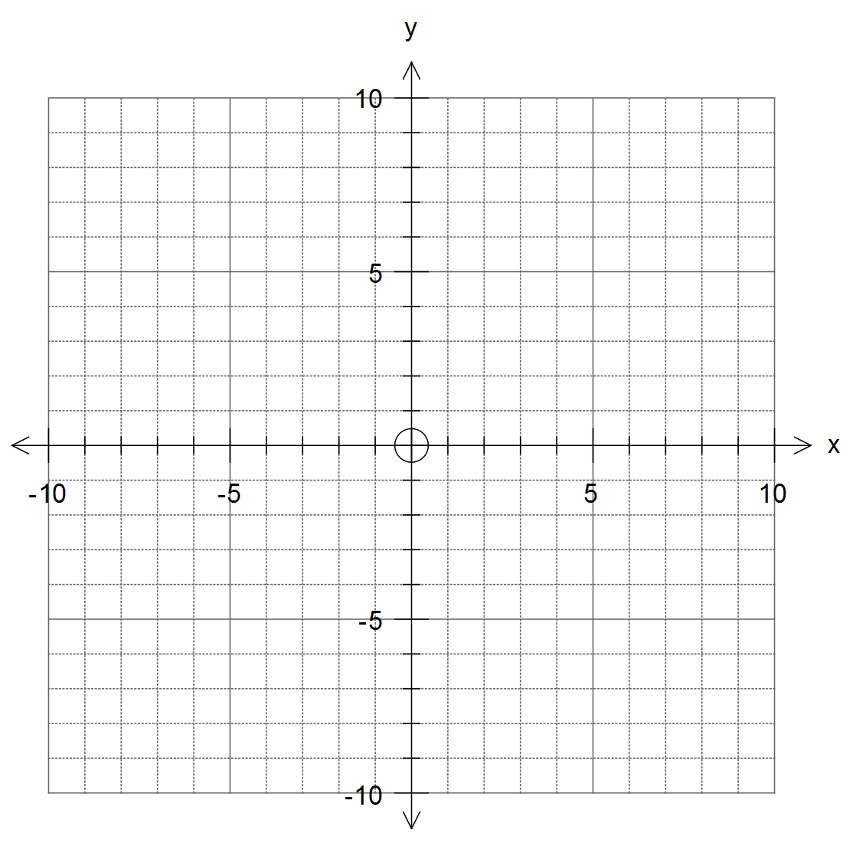

2. (8 marks)  
Find the derivative of each of the following functions.

1. y = 3x4 [1]

1. y = 3x2 – 2x + 5 [2]
2. y = (5x2 + 3)(4x – 5) [3]
3. [2]
4. (7 marks)  
   Given    
   a. Find the gradient of the tangent to . [3]

b. Find the equation of the tangent at . [4]

1. (4 marks)  
   The graph of a function is shown below.   
   Label all significant features of the graph and indicate where the gradient is increasing and decreasing.

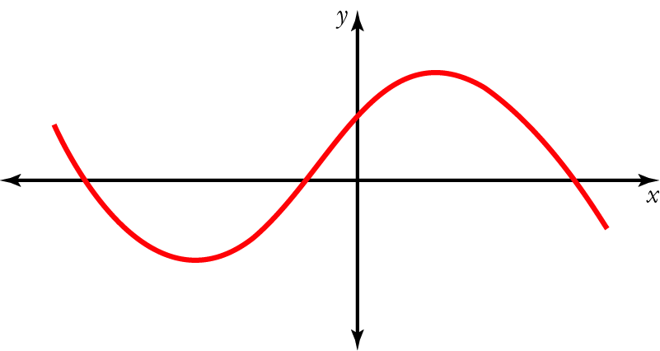

**End of Section One**